Forex-SN-60min:

NZDUSD, NZDJPY, NZDCHF, NZDCAD, GBPUSD, EURUSD, EURNZD, EURJPY, EURCHF, EURCAD, EURAUD, CHFJPY, CADJPY, AUDUSD, AUDCAD,

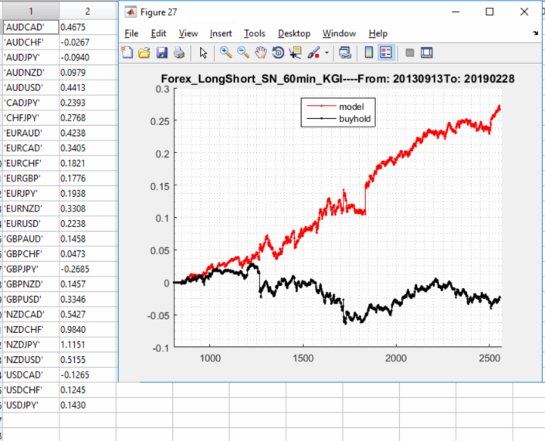

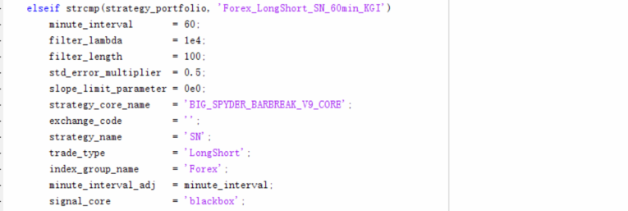

Forex-SP-60min:

USDCAD, NZDUSD, NZDJPY, NZDCHF, NZDCAD, GBPNZD, GBPJPY, GBPCHF, GBPAUD, EURUSD, EURNZD, EURJPY, EURGBP, EURCAD, EURAUD, CADJPY, AUDUSD, AUDJPY, AUDCHF, AUDCAD,

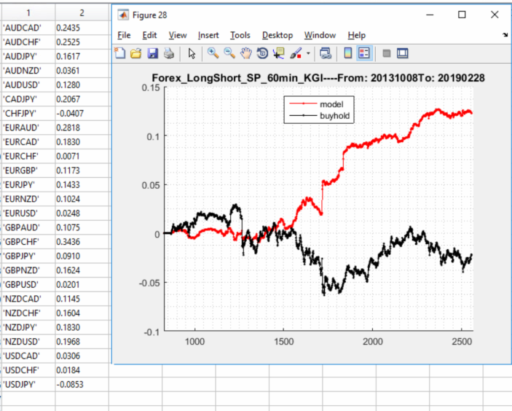

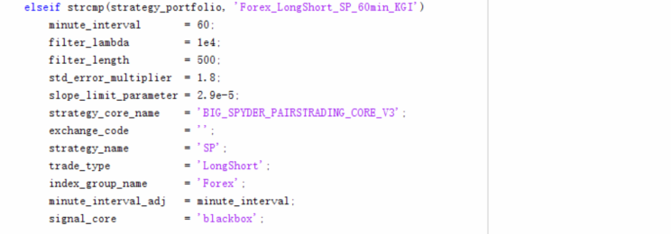

FX-SL-60min:

USDJPY, USDCHF, USDCAD, NZDUSD, NZDCHF, GBPUSD, GBPNZD, GBPJPY, GBPCHF, GBPAUD, EURUSD, EURCHF, EURCAD, CHFJPY, CADJPY, AUDNZD, AUDCHF, AUDCAD,

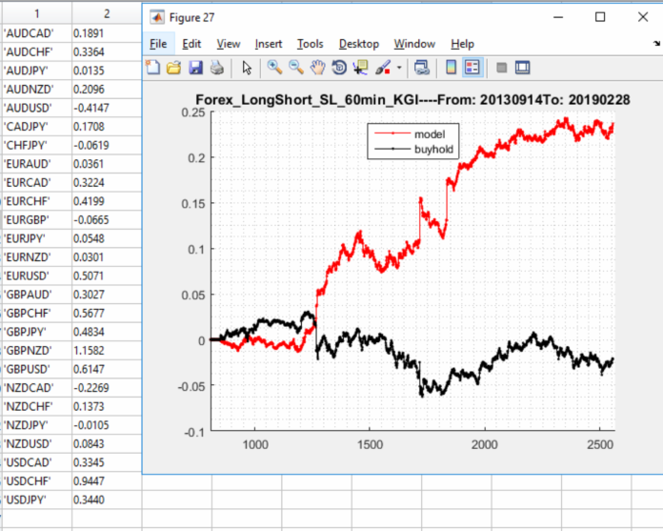

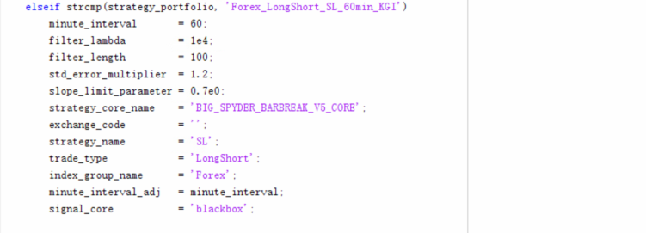

Forex-MR-60min:

USDCHF, USDCAD, NZDJPY, NZDCHF, GBPNZD, EURCHF, CHFJPY, AUDNZD, AUDCAD

? GBPJPY, GBPCHF, GBPAUD, EURNZD, EURJPY, CADJPY, AUDUSD,

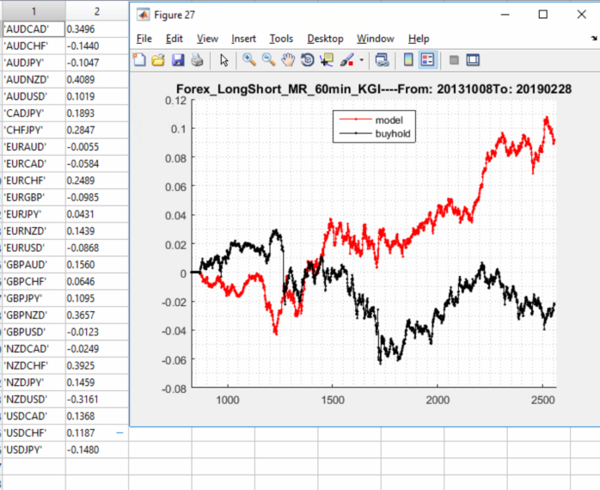

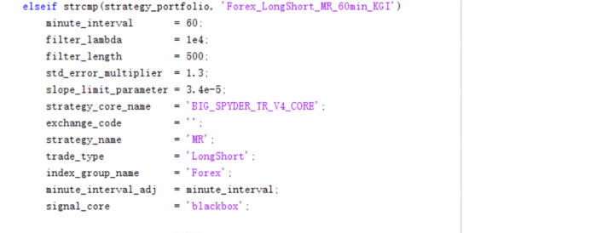

Forex-BT-5min:

USDCHF, NZDJPY, NZDCHF, NZDCAD, GBPUSD, GBPNZD, GBPCHF, GBPAUD, EURNZD, EURGBP, EURCHF, EURAUD, CHFJPY, CADJPY, AUDUSD, AUDNZD, AUDJPY, AUDCHF, AUDCAD

? EURUSD,

Negative: USDJPY,

